

Project Interim Report

On

Password Complexity Validator (Using Core Java & OOP Concepts)
RU-100-05-00018
Object Oriented Programming with Java

SESSION: 2025-26

Submitted By
Jitesh Kumar Chandra
RU-25-10626

Bachelor of Computer Application
with AI and ML in association with Google

Under the Guidance of
Harsh Multani Sir

SCHOOL OF INFORMATION & TECHNOLOGY
RUNGTA INTERNATIONAL SKILLS UNIVERSITY
BHILAI, CG

(April 2026)

Table Of Content

Serial No. | Title | Page Number
 | Abstract | 3
 | Introduction | 5
 | Scope | 7
 | System Requirements | 8
 | Methodology | 9
 | Flowchart | 10
 | Implementation | 11
 | Gantt Chart | 16
 | Conclusions | 19
 | References | 20

Abstract

In the modern digital era, security has become one of the most important aspects of any software system. With the rapid growth of online platforms such as banking, social media, and e-commerce, users are required to create accounts protected by passwords. However, many users tend to create weak passwords that are easy to remember but also easy to guess. This creates a serious security risk and may lead to unauthorized access, data theft, or identity misuse.

The main aim of this project is to design and implement a Password Complexity Validation System using Object-Oriented Programming (OOP) concepts in Java. This system ensures that users create strong and secure passwords by checking whether the password meets certain minimum requirements. These requirements include a minimum length of eight characters, the presence of at least one numeric digit, and the inclusion of at least one uppercase letter.

The project is designed in a modular way by dividing the functionality into different classes. The UserAccount class is responsible for storing user information such as username and password, while the SecurityValidator class is responsible for checking the strength of the password. This separation of responsibilities improves code readability, maintainability, and scalability.

Introduction

In today’s technology-driven world, almost every application requires user authentication. Whether it is logging into a social media account, accessing an email, or performing online banking, users must provide a username and password. Among these, the password plays a crucial role in ensuring the security of the system.

However, many users prefer to use simple and weak passwords such as “123456” or “password” because they are easy to remember. These weak passwords can be easily guessed or cracked using various hacking techniques, which poses a serious threat to data security. Therefore, it is necessary to enforce strong password policies in software systems.

This project focuses on creating a Password Complexity Validator using Java programming language and Object-Oriented Programming principles. The main goal is to ensure that the password entered by the user satisfies certain security conditions before it is accepted. These conditions include minimum length, inclusion of numeric characters, and use of uppercase letters.

The use of Object-Oriented Programming helps in organizing the code into different classes with specific responsibilities. This makes the program more structured, reusable, and easy to maintain. The project also helps in understanding how real-world applications implement validation mechanisms to enhance security.

By developing this project, we not only learn programming concepts but also understand the importance of data protection and secure coding practices. This project serves as a foundation for building more advanced security systems in the future.

Scope

This project is suitable for small-scale applications where basic password validation is required. It can be used in simple registration systems, student projects, or beginner-level applications.

Currently, the system performs basic validation such as checking password length, numeric characters, and uppercase letters. However, the project can be extended in the future by adding more advanced features such as special character validation, password encryption, and database storage.

With further development, this system can be integrated into larger applications such as websites, mobile apps, and enterprise systems to enhance security.

System Requirements

To implement the Password Complexity Validator, the requirements are slightly higher than the stopwatch project because of GUI and regex usage:

Hardware

Processor: Intel/AMD dual-core, 2 GHz or higher

RAM: Minimum 4 GB

Disk Space: 100 MB free

Monitor & keyboard for input/output

Software

Operating System: Windows

Java Development Kit (JDK) 1.8 or above

Java Swing library for GUI components

Methodology

The working of the project follows a step-by-step approach:

First, the user enters the name and password.

A UserAccount object is created to store this information.

The object is passed to the SecurityValidator class.

The system checks the password length (must be at least 8 characters).

It then checks whether the password contains at least one numeric digit.

After that, it checks for at least one uppercase letter.

All conditions are combined to determine whether the password is valid or not.

The result is returned and displayed to the user.

This method ensures that the password is checked step-by-step and only accepted if all conditions are satisfied.

Flowchart

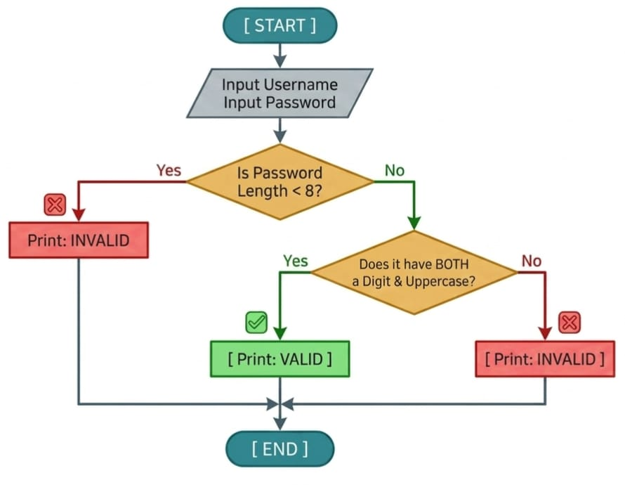

Implementation

The implementation of this program demonstrates how Object-Oriented Programming (OOP) principles can be applied to build a simple yet effective password validation system in Java. The code is divided into three logical parts:

UserAccount Class

This class defines the structure of a user account with two private attributes — username and password.

The constructor initializes these attributes when a new user object is created.

Getter methods (getUsername() and getPassword()) provide controlled access to these private variables, ensuring encapsulation.

By keeping data private, the program maintains security and prevents direct modification of sensitive information like passwords.

SecurityValidator Class

This class contains the core logic for password validation.

The method isValid(UserAccount user) retrieves the password from the user object and checks whether it meets the defined criteria:

Minimum length of 8 characters

At least one digit

At least one uppercase letter

A loop iterates through each character of the password, using built-in Java methods Character.isDigit() and Character.isUpperCase() to identify digits and uppercase letters.

Two boolean flags (hasDigit, hasUppercase) track whether these conditions are satisfied.

If both flags are true and the length condition is met, the method returns true, indicating a valid password; otherwise, it returns false.

This approach ensures that password validation is systematic, efficient, and reusable.

finalproject Class (Main Class)

The main() method serves as the entry point of the program.

It uses the Scanner class to take user input for both username and password directly from the console.

A UserAccount object is created using the entered data, and a SecurityValidator object performs the validation.

Based on the result, the program prints either:

"Your Password is VALID" — if all conditions are met.

"Your Password is INVALID" — if any condition fails.

The use of console input/output makes the program interactive and easy to test.

Finally, the scanner is closed to prevent resource leaks.

Execution Flow

User enters their username and password.

The program checks the password length.

It verifies the presence of at least one digit and one uppercase letter.

If all criteria are satisfied → displays VALID message.

Otherwise → displays INVALID message.

A sample execution of the project is as follows:

Sample Output 1:

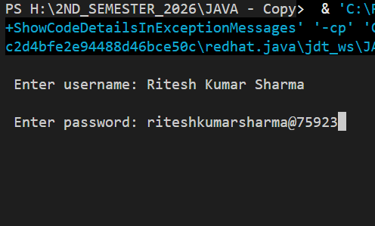

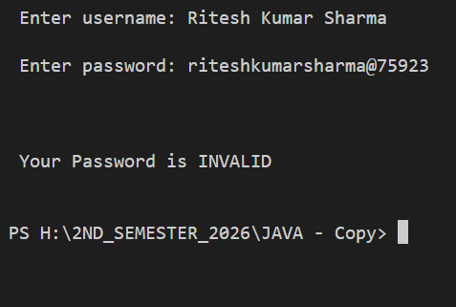

Sample Output 2:

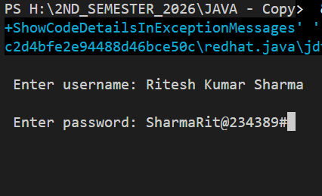

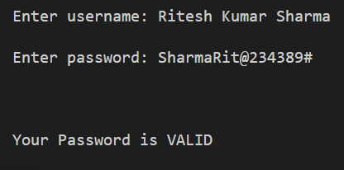

Gantt Chart

The Gantt chart for this project illustrates the timeline and workflow followed during the development of the Password Complexity Validator using Object-Oriented Programming (OOP) in Java. It provides a structured view of how the project progressed through different stages, ensuring efficient planning and timely completion.

Day 1 — Planning and Design

On the first day, the focus was on understanding the project concept and preparing the theoretical framework. Tasks included:

Studying password validation requirements and security rules.

Writing the Introduction, Objectives, Scope, and System Requirements sections.

Designing the Flowchart and Class Diagram to visualize how the program would function. This stage established the foundation for the coding phase by defining the logic and structure of the validator.

Day 2 — Coding and Implementation

The second day was dedicated to the practical development of the project. Tasks included:

Writing the Java code for the UserAccount and SecurityValidator classes.

Implementing the validation logic to check password length, presence of digits, and uppercase letters.

Testing the program with different inputs to ensure accurate validation results. This day represented the core technical phase, where theoretical design was transformed into a working program.

Day 3 — Documentation and Finalization

On the third day, the remaining documentation work was completed. Tasks included:

Preparing the Gantt Chart, Conclusion, and References sections.

Reviewing and formatting the report for submission.

Verifying that all project components — code, flowchart, and explanation — were consistent and well-organized. This stage ensured that the project was presented professionally and ready for evaluation.

TASK | DAY 1 | DAY 2 | DAY 3
Understanding Project Concept and Preparing the Theoretical Framework | ✓
Writing Report up to Flowchart Heading | ✓
Coding the Password Complexity Validator in Java |  | ✓
Testing and verifying output |  | ✓
Preparing Gantt Chart |  |  | ✓
Writing Conclusion |  |  | ✓
Adding References |  |  | ✓

Conclusion

This project successfully demonstrates the implementation of a Password Complexity Validation System using Object-Oriented Programming. It helps in understanding how secure password policies are applied in real-world applications.

By separating user data and validation logic, the system becomes more organized and maintainable. The project also improves programming skills and highlights the importance of cybersecurity.

Overall, this project provides a strong foundation for developing secure applications in the future.

Reference

H. Schildt, Java: The Complete Reference, 11th ed. New York: McGraw-Hill, 2018.

Oracle, “Java Regular Expressions,” Oracle Documentation. [Online]. Available:

https://docs.oracle.com/javase/tutorial/essential/regex/ (docs.oracle.com in Bing)

Oracle, “Swing Tutorial,” The Java™ Tutorials. [Online]. Available:

https://docs.oracle.com/javase/tutorial/uiswing/ (docs.oracle.com in Bing)

